**Sudo:**

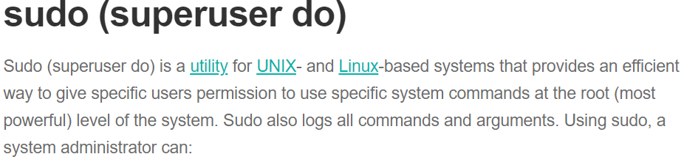

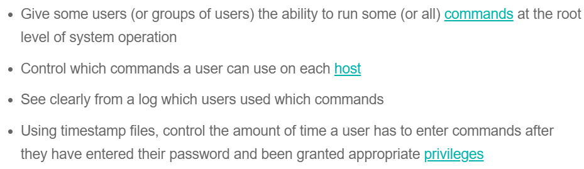

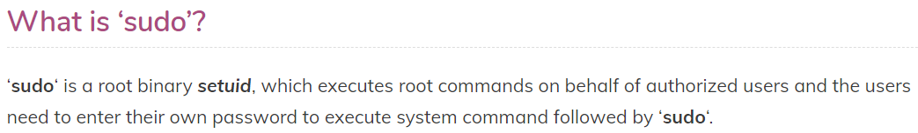

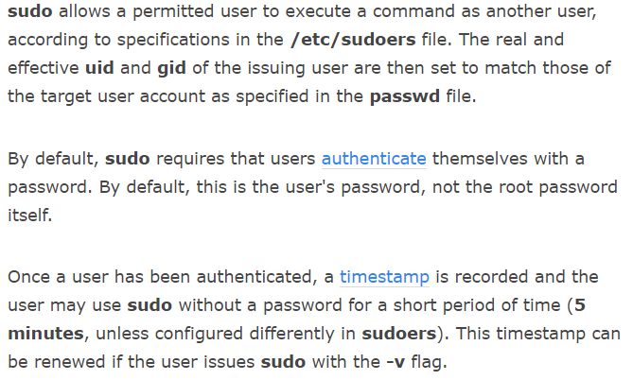

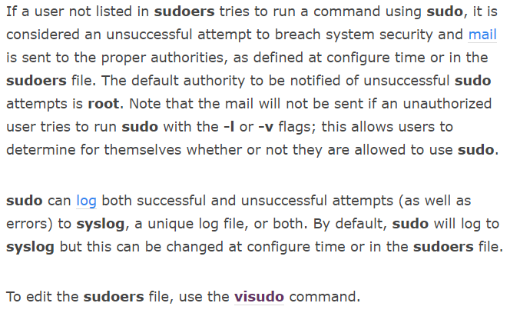

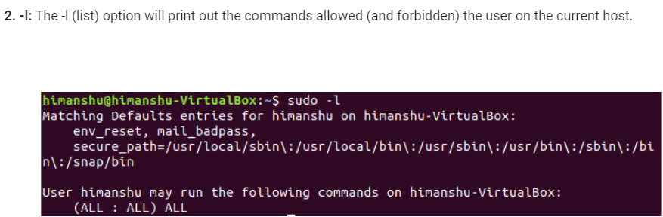

**Visudo:**

* We can run **‘/usr/sbin/visudo‘** to add/remove the list of users who can execute ‘sudo‘.
* visudo edits the sudoers file, which defines the users and groups with administrator rights.

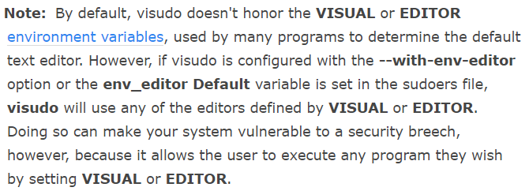

**Granting sudo access:**

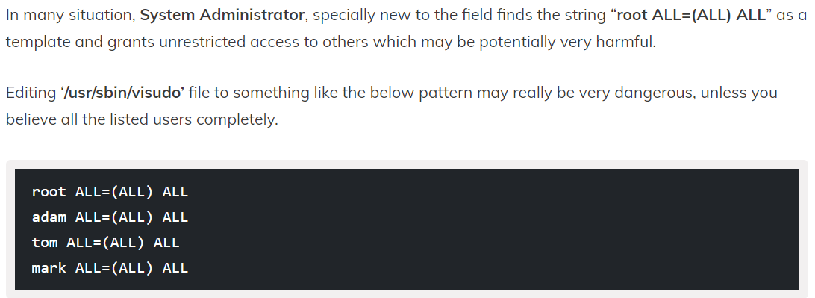

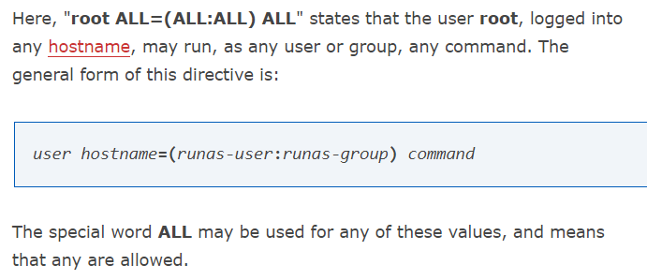

**Parameters of sudo:**

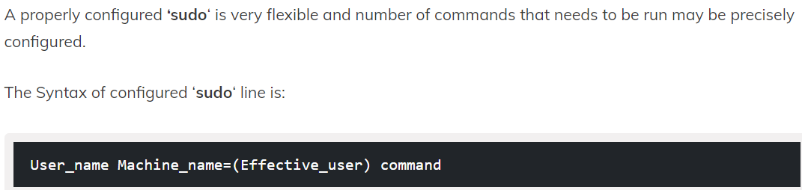

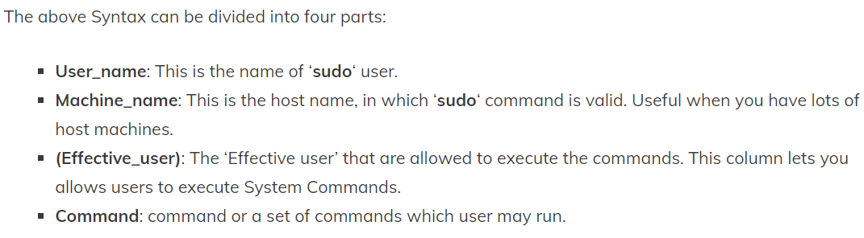

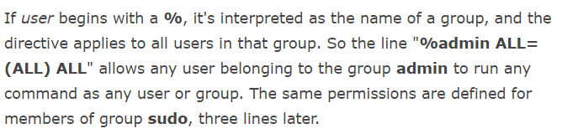

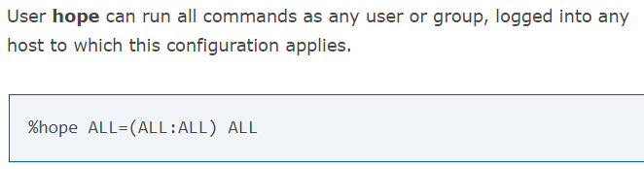

**Examples:**

